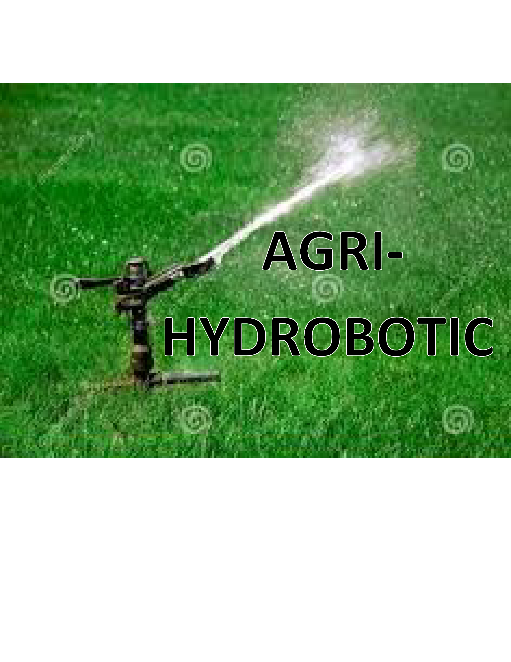

*BY,*

***IQRA SIDDIQUI.***

Category: I.T

Institute: AKHSS

(Aga Khan Higher Secondary School, Karachi)

* INDEX

|  |  |  |
| --- | --- | --- |
| S.NO | TOPICS | PG# |
| 1) | Abstract | 3 |
| 2) | Literature Review | 4 |
| 3) | Introduction | 5 |
| 4) | Method | 6 |
| 5) | Water Sources for Agri-hydrobotic |  |
| 6) | Working of Components |  |
| 7) | Comparison with Existing systems |  |
| 8) | Inspired By System |  |
| 9) | Result | 7 |
| 10) | Working Model |  |
| 11) | Conclusion | 8 |
| 12) | References | 9 |
|  |  |  |

* ABSTRACT

**AGRI-HYDROBOTIC**

Water, the fundamental component for the life on Earth is unfortunately in a serious scarcity. 91% represents the irrigation of the water consumption, however the production is dreadfully low as more than half is wasted due to evaporation or leaking in the water networks.

Each year a variety of crops are wasted due to the, more than adequate or inadequacy of water. Although many countries have installed water showers to water the fields, however these showers often lead to an excess of water in the fields thus the crops and water, both are wasted.

The Agri-hydrobotic will be programmed to detect the type of plants in a particular field and water them as required. It’s all 8 arms will be capable of throwing water to a larger area in the field in multiple directions. Moreover the sensor will sense that all the plants in a field have received the water and if not, then the robot will track the un-watered plant.

It will comprise of

* Robot kit
* Robotic arms
* Sensors
* Software

The Agri-hydrobotic will be quick and cheap as a number of water showers can be replaced by single Agri-hydrobotic. The "Agri-hydrobotic” is a step in promoting the modern technology in agriculture and water management. Moreover, it will also contribute to the slogan of "Save water" as every crop will get the water according to the requirement and will not be wasted.

* LITERATURE REVIEWS
* “There are a number of ways in which automated systems could improve crops and ‘remove some of the hard tedious work from greenhouses’.

- Daniela Rus, director of MIT's Distributed Robotics Laboratory

* “Mechanization has come about in a number of ways”

- Philip Martin of the University of California, Davis.

* “A potted plant in a container measuring 6 inches in diameter needs water when the top 2 inches of soil feels dry to the touch. A larger container measuring 8 to 10 inches in diameter is ready for water when the top ½ to 1 inch of soil feels dry.”

- General Rule

* Solar PV uses about 21 times less water than nuclear power (per kilowatt-hour of electricity produced), about 16 times less water than coal power, and about 8 times less water than a combined cycle power plant

- [Study from the Virginia Water Resources Research Center](http://spectrum.ieee.org/energy/environment/how-much-water-does-it-take-to-make-electricity)

* INTRODUCTION

Water management is the hot potato right now. The Agri-hydrobotic is an innovation in the field of agriculture for the advancement of agricultural particularly irrigation and water management sector. This device will detect the type of plant and its water requirement and water them. Also it will ensure that all the plants in the field are watered. Agri-hydrobotic consists of the major components including humidity level detector, the soil sensor, LIDAR sensor, and robotic kit. Moreover the device will use solar technology for charging that will ultimately reduce the cost of maintenance and increase the sustainability. The device can be very productive and assist in number of ways. The countries like Pakistan, Liberia, and Central African Republic that are dependent over agriculture for economy, particularly California where there is water shortage and has a multi-billion dollar agriculture can greatly benefit from Agri-hydrobotic as for such countries wastage of any crop is a great strain on economy. It is a device initially designed for the large scale subsistence but with a little modification can be used in small scale subsistence too proving to be much feasible and covering most of the dimensions of the requirements of crops and the farmer. It is an innovation in the automated irrigation systems, however Agri-hydrobotic is much more beneficial and can replace them as due to this old technology excess of water takes place in the crops while the proposed innovation is organize on the basis of saving water by avoiding water excess in plants It will have a fecund effect on the entire agricultural and water sector. The number of water showers in the field can be replaced by a single Agri-hydrobotic. According to a survey by 2050, the population will rise from 7.3 billion now to 9.7 billion, therefore there is an uprising need to compensate the water scarcity and Agri-hydrobotic is a step in providing solution to this menace.

* METHOD

It is an innovation in the irrigation system according to the detection of crop requirement. The device will be first switched on by the solar energy. It will have solar battery connected with a short solar panel proving to be a “solar plus storage”. The working of the Agri-hydrobotic will proceed in three major steps. Firstly the soil sensor will detect the moisture in the soil to check for the plant that has not been watered. According to the general rule “a potted plant in a container measuring 6 inches in diameter needs water when the top 2 inches of soil feels dry to the touch. A larger container measuring 8 to 10 inches in diameter is ready for water when the top ½ to 1 inch of soil feels dry.” Using this general phenomenon and the algorithm provided for the characteristics and requirements of the plants in a specific field the working will proceed. Then the humidity sensor will detect the humidity level. By the theoretical results we conclude that if the humidity level is higher, the water usage of plants is much slower while if level is quite low, the plants will use a much larger amount of water thus the third step proceeds according to the humidity results. According to the requirements, electronic controlled valves installed with underground pipeline will be given a signal to allow the water to flow and plants will be watered. If the moisture in the soil is adequate and plant’s water requirement is already fulfilled then it will proceed to the next plant. This is the procedure that will be followed in case of large scale subsistence.

Agri- hydrobotic can also be organize for small scale. For this purpose the device instead of comprising of a separate water system of underground pipelines and controlled valves, it will have a built-in water tank fixed with it that will behave as a water source for the automation.

Another benefit that can be taken from Agri-hydrobotic is to make them useful in fields where different types of plants with different water requirements are planted. For such cases LIDAR system can be used. The algorithm of the device will be adjusted to make it understand different plants placed at different coordinate of the field and to proceed the working of Agri-hydrobotic. In recent years, a lot of engineers and botanic are carrying out experiments to provide efficiency and increase in the productivity in the agricultural department. According to Daniela Rus, the automated systems can be utilize to improve efficiency and reduce hard work. Agri-hydrobotic will meet this demand. Thus saving time and increasing the efficiency of the production. Moreover the device will be using solar battery as a source of power. According to a study Solar PV uses about 21 times less water than nuclear power, therefore using it will also promote in water conservation. Thus Agri-hydrobotic will be leading to a cost free and sustainable agriculture.

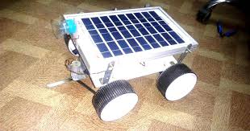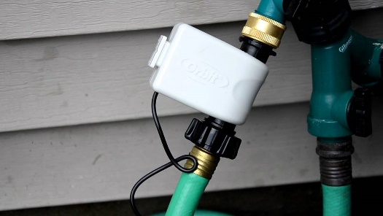

* WATER SOURCES FOR AGRI-HYDROBOTIC

The Agri-hydrobotic will be provided with water either of the two sources:

* Electronic valve system
* Built in water tank

**ELECTRONIC VALVE SYSTEM:**

The Agri-hydrobotic using this water source will be connected with another irrigation system. It will be connected with the electronic automated valves installed on the underground pipeline. The pipes will be linked to a lake or other water body. For every water inadequacy, the Arduino will give signal to the valve. On receiving the signal water will be allowed to flow and the plants in that segment will be watered.

The plants in the field will be divided into smaller segments.

For instance, for a field of 100 x 100, the Agri- hydrobotic will detect the water requirement using soil and humidity sensors at every 10 ft. As soon as the water is inadequate, the signal will be sent to the valve and it will be watered.

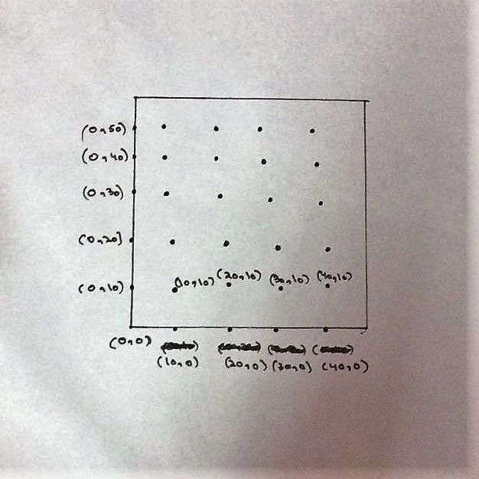

*A Field of 100 x 100*

**WATER TANK SYSTEM:**

Another technique that Agri-Hydrobotic will be using for water is the tank system. It will have a water tray, basically a water reservoir at the bottom that will be connected to a pump motor. The pump motor will fetch the water from reservoir and water the plants accordingly. This technique is applicable and cost effective on the small scale subsistence. Human intervention will be required to fill the reservoir when it gets empty.

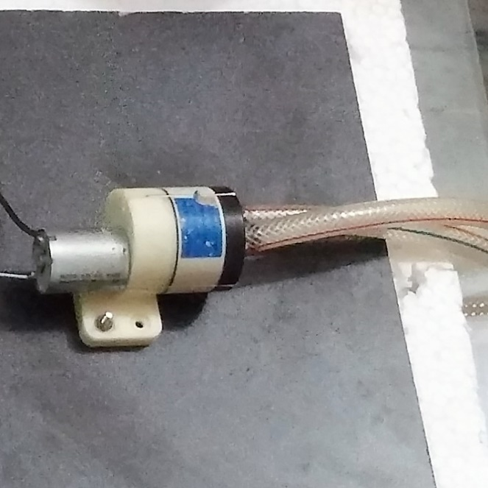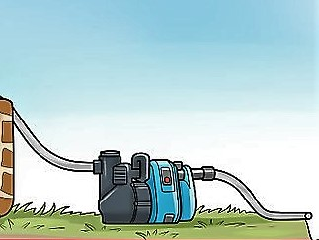

* WORKING OF THE COMPONENTS
* **SOIL SENSOR**

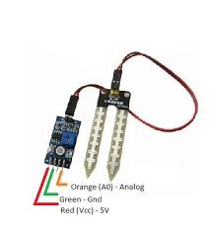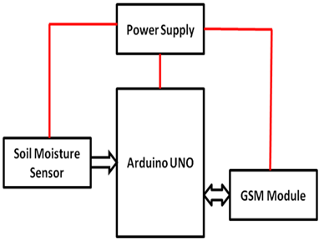

* **HUMIDITY AND TEMPERATURE DETECTOR**

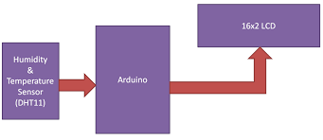

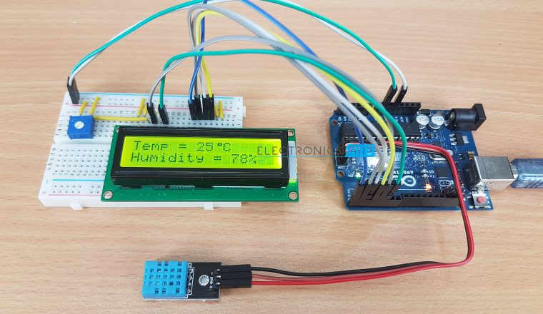

* **LIDAR SENSOR**

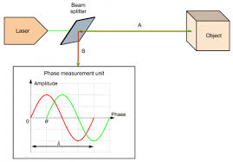

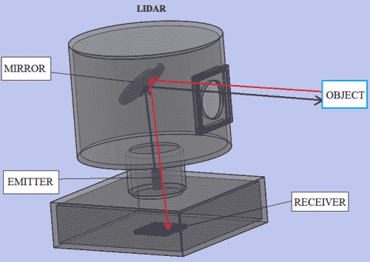

* **SOLAR BATTERY**

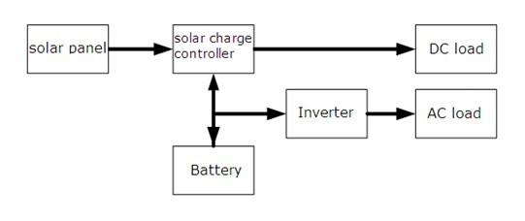

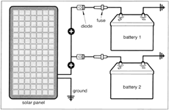

* COMPARISON WITH EXISTING SYSTEMS
* The existing modern irrigation systems though are very efficient and playing a role to provide ease to the farmers however they are either unaffordable by the small farmers or do not meet the irrigation requirements of the crops.
* Furthermore the advancements in the irrigation and water management part of agriculture are limited and mostly devices being used are mechanical that are often misunderstood by the people as artificial intelligence.
* Agri-hydrobotic is an innovation in the automated irrigation systems purely based on the IT i.e. artificial intelligence.
* It will prove to be much useful in almost all the fields either large scale or small scale, and for a single type of plant or multiple type of plants in a field.

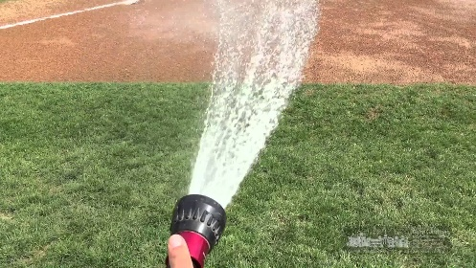

|  |  |
| --- | --- |
| **Existing Systems** | **Agri-hydrobotic** |
| Most of them are expensive due to the modern technology used. | It will be designed in a way to be cost effective as no expensive components are used. |
| Most of the robotic innovations are taking place in agriculture field particularly as a complete agriculture package including cutting, harvesting etc. The use of such complete packages is useless to a lot of farmers. | Agri- hydrobotic will be contributing to agriculture particularly the water management side which is the hot potato. |
| It also leads to Water wastage.  For e.g. automated sprinkler system | It is a step against the water scarcity as plants will be watered according to the adequacy requirement. |

* SOME MODERN WATERING SYSTEMS

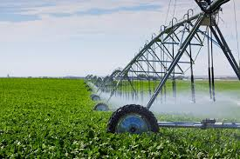

Irrigation system used in South Africa

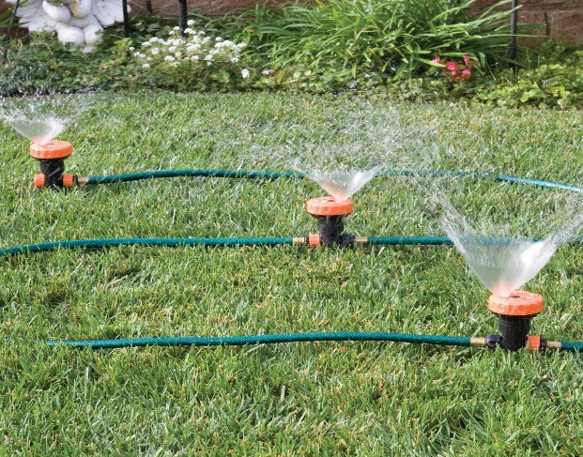

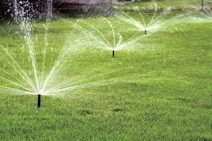

Sprinkler irrigation system

* INSPIRED BY SYSTEMS

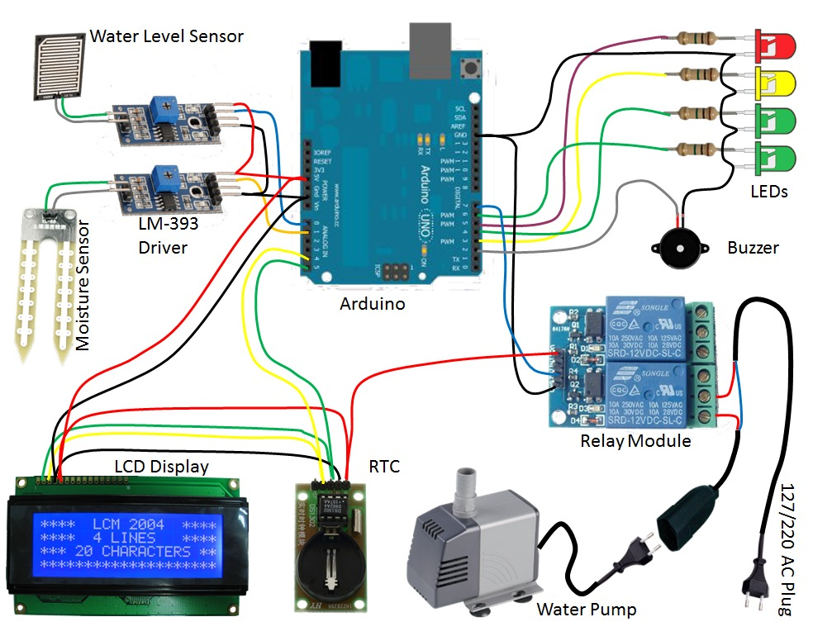

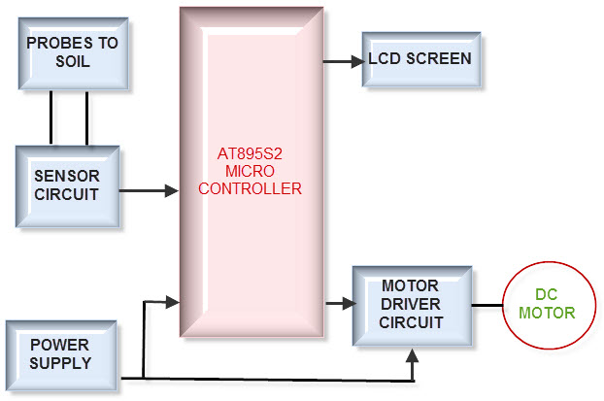

* RESULT

The Agri-Hydrobotic will prove to be a feasible, affordable, sustainable and efficient innovation in the field of agriculture. It can reduce the water scarcity to about 40% – 60%. It can be used by those countries that are greatly dependent over agriculture in terms of economy like Pakistan. The "Agri-hydrobotic” is a step in promoting the modern technology in agriculture and water management. Moreover, it will also contribute to the slogan of "Save water" as every crop will get the water according to the requirement and will not be wasted.

If bring in action, it can be modified enough to be used as a complete agriculture package for fields comprising of pesticides, fertilizers and all other requirements of plants.

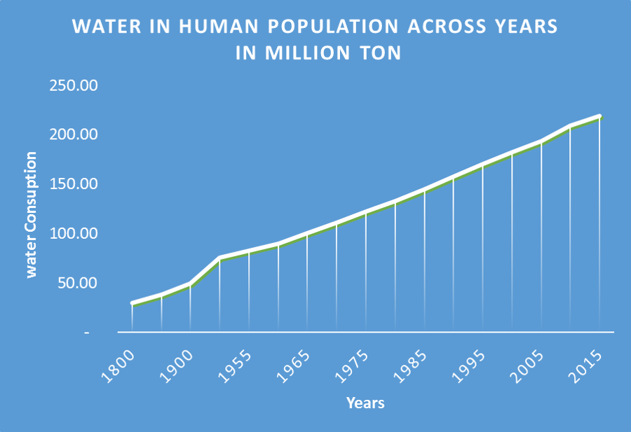

* WORKING MODEL

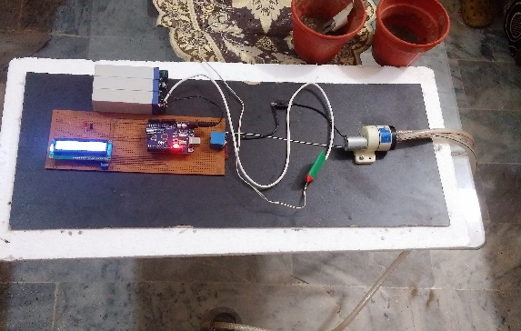

**STAGE 1**



**STAGE 2**



**STAGE 3**

* CONCLUSION

The "Agri-hydrobotic” is a step in promoting the modern technology in agriculture and water management. It is an innovation in the automated irrigation system. It’s working principle deals with the detection of water requirement of the plants and water them accordingly in order to avoid the wastage of crops due to excess or inadequacy of water. Moreover about 70% of the water assigned for agriculture is wasted thus it will also contribute to the slogan of "Save water" as every crop will get the water according to the requirement and will not be wasted... The Agri-hydrobotic is a step towards sustainable agriculture as it will use solar technology for charging that will ultimately reduce the cost of maintenance and increase the sustainability. It is a device initially will be design for the large scale subsistence but with a little modification can be used in small scale subsistence too, proving to be much feasible and covering most of the dimensions of the requirements of crops and the farmer. According to Daniela Rus, the automated systems can be utilize to improve efficiency and reduce hard work. Agri-hydrobotic will meet this demand. The working of the Agri-hydrobotic will proceed in three major steps. Firstly the soil sensor will detect the moisture in the soil to check for the plant that has not been watered, then the humidity sensor will detect the humidity level and then according to the requirements, electronic controlled valves installed with underground pipeline will be given a signal to allow the water to flow and plants will be watered.

The device can be very productive and assist in number of ways. The countries like Pakistan, Liberia, Central African Republic that are dependent over agriculture for economy, particularly California where there is water shortage and great dependence over economy can greatly benefit from Agri-hydrobotic as for such countries wastage of any crop is a great strain on economy. In a nutshell, Agri-hydrobotic will be leading to a cost free and sustainable agriculture.

* REFERENCES

<http://www.economist.com/technology-quarterly/2016-06-09/factory-fresh>

<https://cleantechnica.com/2014/09/22/solar-energy-advantages-vs-disadvantages/>

https://www3.epa.gov/region9/waterinfrastructure/agriculture.html

<https://www.gardeningknowhow.com/garden-how-to/soil-fertilizers/testing-moisture-in-plants.htm>

<http://www.pthorticulture.com/en/training-center/how-does-humidity-influence-crop-quality/>

[Study from the Virginia Water Resources Research Center](http://spectrum.ieee.org/energy/environment/how-much-water-does-it-take-to-make-electricity)

Philip Martin of the University of California, Davis

Daniela Rus, director of MIT's Distributed Robotics Laboratory